Types of Determiners
# Source: AI Source: Provided by: [Data Path: Persons Table -> ID Column: 1, Name_En Column: Motasem Essam] -> From: [Chatgpt (GPT-4-turbo)] on [7/28/2025]
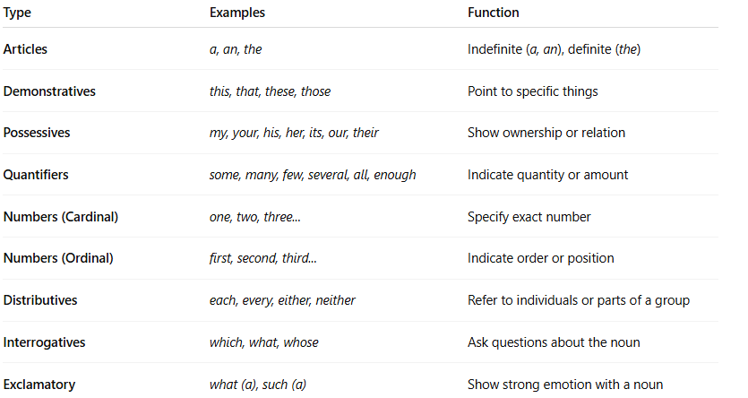

Type | Examples | Function
Articles | a, an, the | Indefinite (a, an), definite (the)
Demonstratives | this, that, these, those | Point to specific things
Possessives | my, your, his, her, its, our, their | Show ownership or relation
Quantifiers | some, many, few, several, all, enough | Indicate quantity or amount
Numbers (Cardinal) | one, two, three... | Specify exact number
Numbers (Ordinal) | first, second, third... | Indicate order or position
Distributives | each, every, either, neither | Refer to individuals or parts of a group
Interrogatives | which, what, whose | Ask questions about the noun
Exclamatory | what (a), such (a) | Show strong emotion with a noun

